03rd November 2016

Preparations for WTCC Final race of the season in Qatar

The season-closing night racing spectacular will be held in Qatar later this month from 24th-25th November.

The Losail International Circuit in Qatar, will bring new emotions and thrills after an intense eight months of FIA World Championship touring car racing which has taken place in Africa, Asia, Europe and South America and which boasts the Japanese premium tyre manufacturer YOKOHAMA as exclusive tyre supplier.

With the Driver’s World Championship title, already in the hands of the superb Jose Maria “Pechito Lopez” from Argentina, who has carved his legendary three year stint at the FIA WTCC with three World Championship’s for himself and Citroen Racing, the excitement in Qatar remains to see who will be runner-up. Four times World Champion Yvan Muller, who recently announced his retirement from WTCC at the end of the season, is well placed to manage the silver spot. In direct competition and only a few points behind, Honda’s Tiago Monteiro will also want to take the silverware in the last race of the season in a fiery veteran head to head “clash of titans”. Meanwhile the third spot in the podium is also up for grabs, theoretically at least, for Norbert Michelisz who is currently fourth and Rob Huff also with an outside chance in fifth.

This year the independent Trophy was won by Mehdi Bennani who managed to keep Tom Chilton at bay, by a few points whilst the manufacturers Championship went to Citroen, who will no longer continue with a works team next season.

The WTCC Race of Qatar will take place on a Friday. It will be the Championship’s second ever night race following from the successful inaugural edition in 2015, also in Qatar.

Meanwhile a spokesman for YOKOHAMA Europe has expressed satisfaction that throughout the season, YOKOHAMA’s Motorsport Support team has been working diligently to ensure the highest performance is achieved at all races offering the necessary technical advice and support to all teams to ensure the highest level of competition.

Drivers Championship Standings:

1 Jose Maria Lopez Argentina 361
2 Yvan Muller France 235
3 Tiago Monteiro Portugal 204
4 Norbert Michelisz Hungary 190
5 Rob Huff UK 180

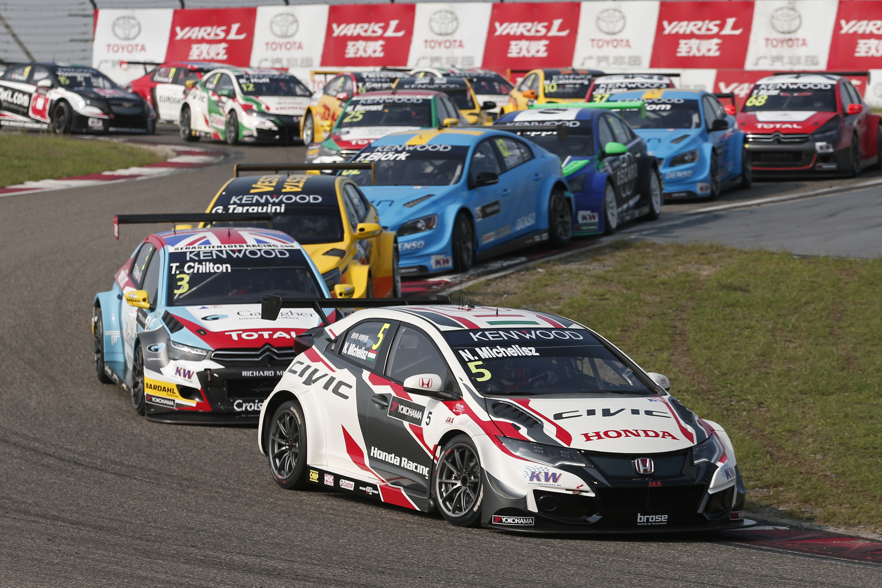
Thrills in the FIA WTCC

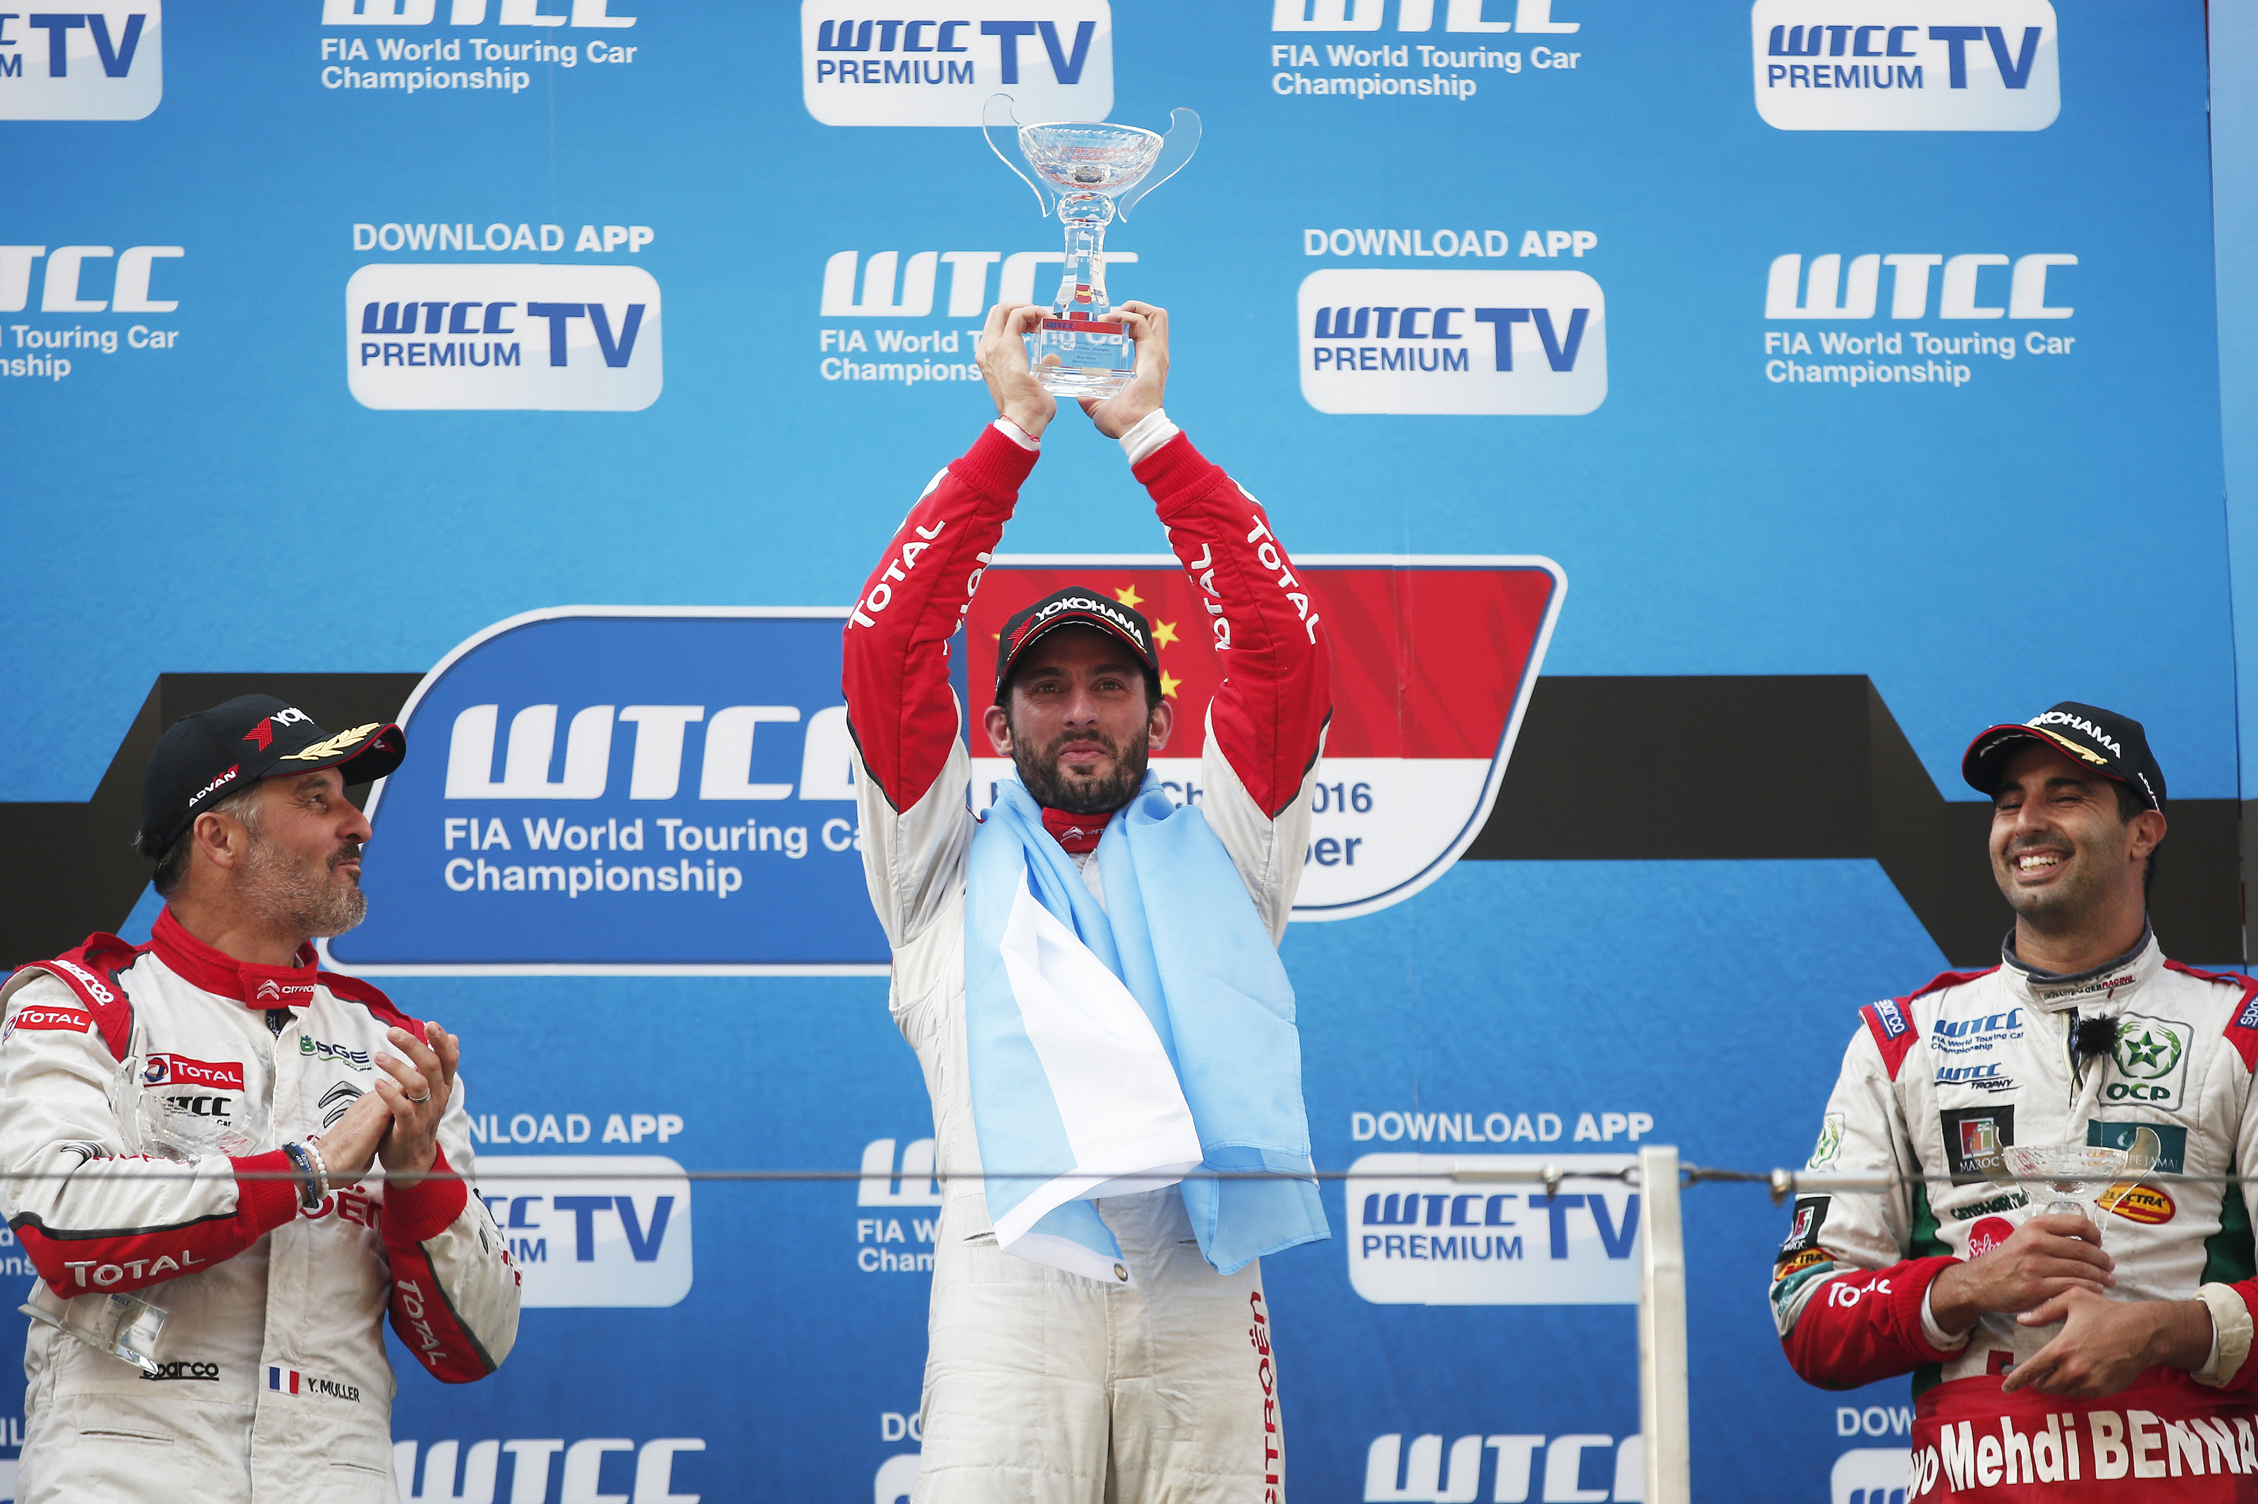
Lopez celebrates WTCC victory with Muller and Bennani in the podium

